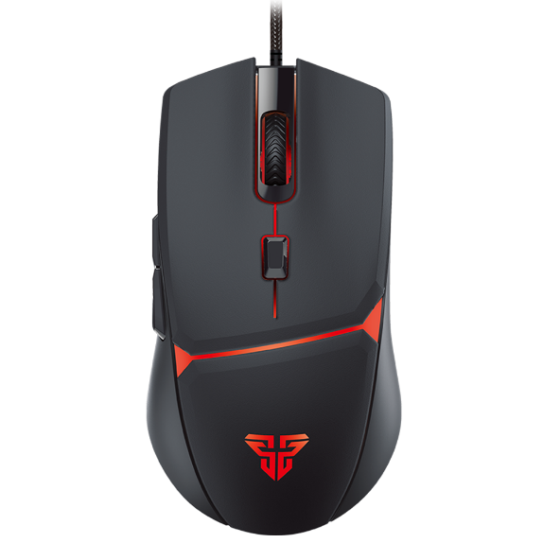

Kebidu 2.4G Wireless Mouse Rechargeable LED Luminous Mute Gaming Mice For PC Computer Laptop

* Photoelectric resolution: 1600dpi (dpi)
* Number of keys: 4 (keys)
* Wireless transmission frequency: 2.4GHz
* Operating distance: 10 (m)

MOUSE